TRANSPORT SYSTEM PLANNING LABORATORY
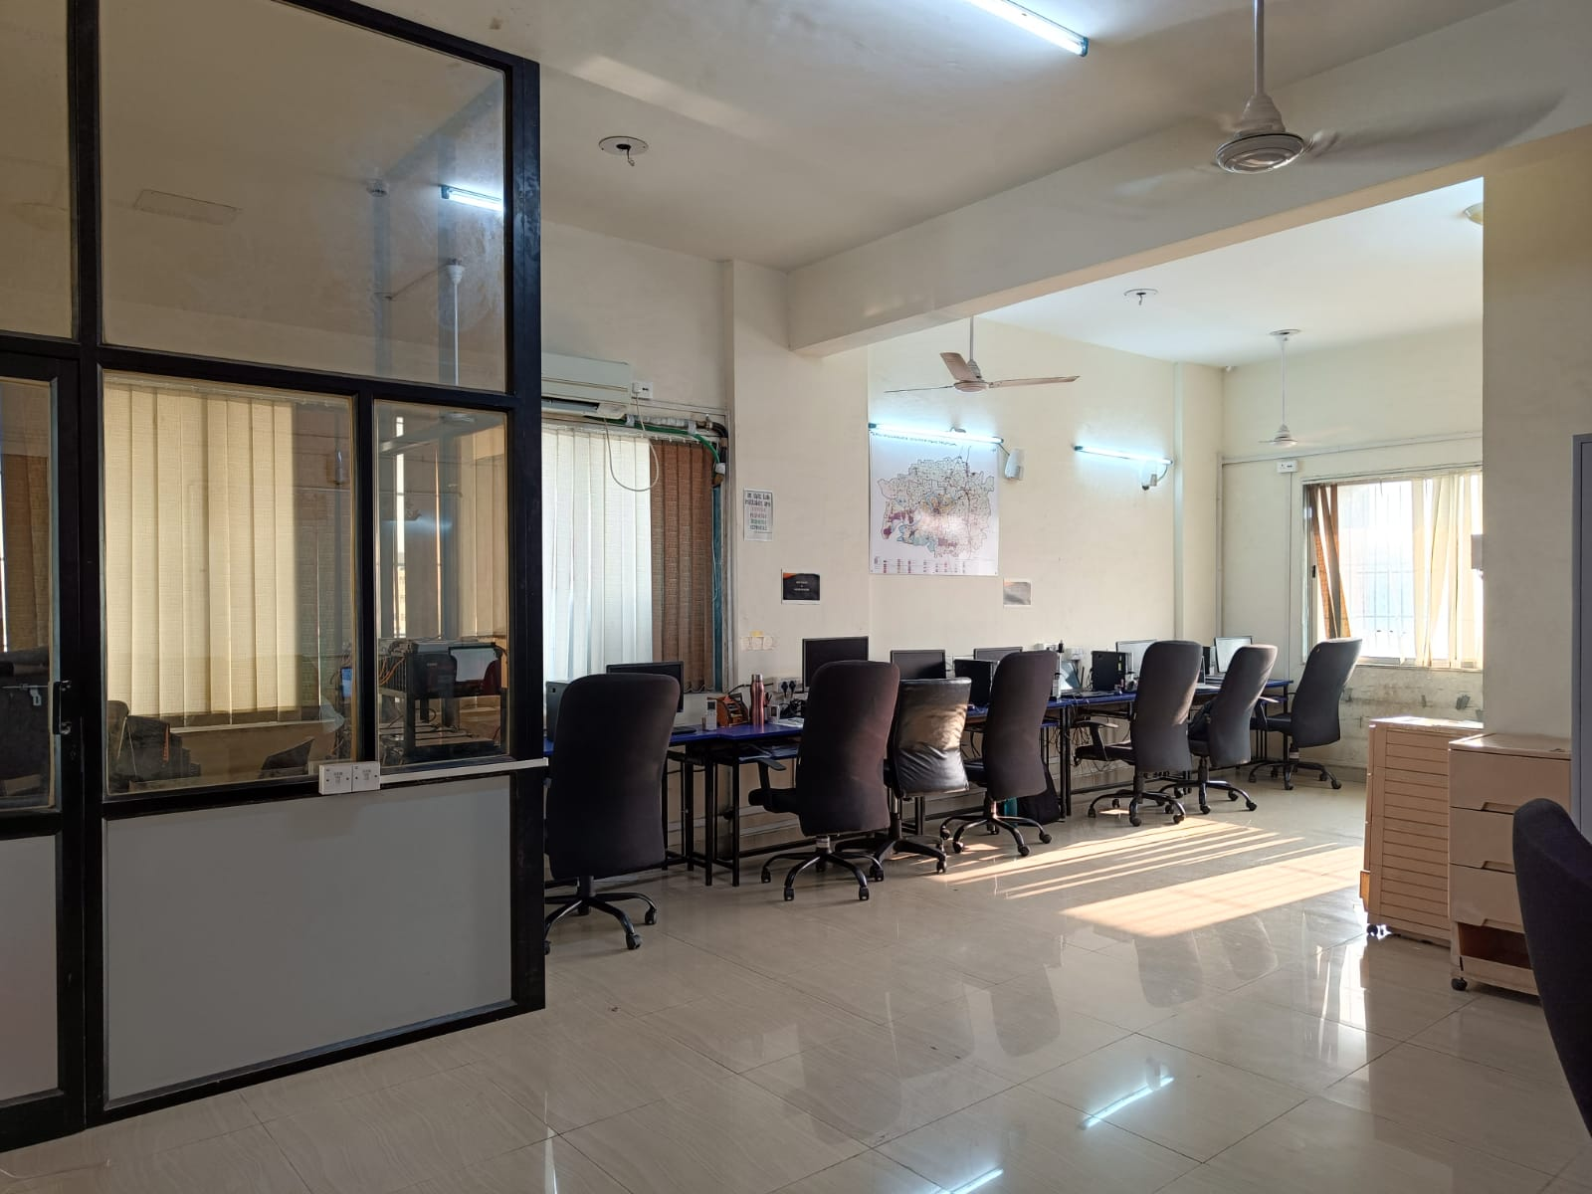

The transportation system planning laboratory is equipped with 10 computer systems and software such as CUBE, VISSUM, and N-logit for the planning and design of urban transportation systems. Development of travel demand modelling for the cities of SURAT and NAVI MUMBAI, Travel Demand estimate of Dream city project, Evaluation of transit service performance, increasing transit usage in India's metropolitan cities and developing a guidebook on trip generation for Indian cities are among the research and consultancy projects conducted at this laboratory. In this laboratory, students are exposed to a variety of assignments related to the development of a comprehensive mobility plan, the feasibility of urban transport projects, and the modelling of urban transportation system.

